Log Tool User’s Guide

Contents
1. Introduction

2. Log Command
1) Login Log
2) Map Log

3. Using Log Tool

Connect Log Tool
Log Search
Log Result
Save Log File

1. Introduction

Welcome to Log Tool – the game operator software to find Game Log.

About Log Tool

Log Tool can be searched the created log with various conditions in Log Server
Log Server saves the log delivered by Game Server.

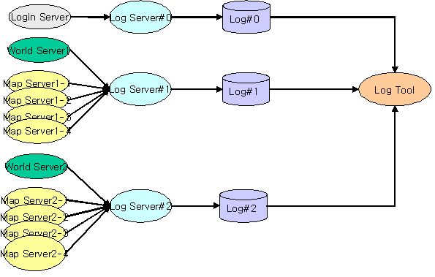
<Game Log system construction >

2. Log Command

Login Log

- Log created from Login Server
- It records the log related with game connection & character creation or delete

Kind | Command | K0 | K1 | K2 | K3 | K4 | K5 | K6 | Log
Connect | Login | Acc |  |  |  |  |  |  | TEXT
Char | Char Create | Acc | Player | Country | Race | Class | Sex |  | CHARBASE
Char | Char Del | Acc | Player | Country | Race | Class | Sex | Lv | CHARBASE
Char | Game Start | Acc | Player | Country | Race | Class | Sex | Lv | CHARBASE

Map Log

- Log created from Map Server

Kind | Command | K0 | K1 | K2 | K3 | K4 | K5 | K6 | Log
Connect | ENTERMAP | Acc | Player |  |  |  | Now Money | Now Exp
Level Up | LEVELUP | Acc | Player |  |  |  |  | Up Level
UserDie | USERDIE | Acc | Player |  |  |  |  | Type
Monster | MONSPAWN |  |  | Mon
Monster | MONDIE | Acc |  | Mon
Monster | MONMONEYSOLOE | Acc | Player | Mon |  |  | Money |  | bWorld
Monster | MONMONEYPARTY | Acc | Player | Mon |  |  | Money |  | bWorld
Monster | MONEXPSOLO | Acc | Player | Mon |  |  |  | Exp | bWorld
Monster | MONEXPPARTY | Acc | Player | Mon |  |  |  | Exp | bWorld
Monster | ITEMBYMONSOLO | Acc | Player | Mon | Item |  | Money
Monster | ITEMBYMONPARTY | Acc | Player | Mon | Item |  | Money
Monster | ITEMBYWORLD | Acc | Player | Mon | Item |  | Money
ITEM | ITEMDEL | Acc | Player |  | Item |  |  |  | LF_ITEM
ITEM | ITEMBUY | Acc | Player | NPC | Item |  | Money |  | LF_ITEM
ITEM | ITEMSELL | Acc | Player |  | Item |  | Money |  | LF_ITEM
ITEM | ITEMUSE | Acc | Player |  | Item |  |  |  | LF_ITEM

Kind | Command | K0 | K1 | K2 | K3 | K4 | K5 | K6 | Log
Upgrade | ITEMUPGRADESUCCESS | Acc | Player |  | Item |  |  | Up Level | LF_ITEM
Upgrade | ITEMUPGRADEFAILDEL | Acc | Player |  | Item |  |  | Up Level | LF_ITEM
Upgrade | ITEMMAKESUCCESS | Acc | Player |  | Item |  |  | Up Level | LF_ITEM
Upgrade | ITEMMAKEZERO | Acc | Player |  | Item |  |  | Itemlevel | LF_ITEM
Upgrade | ITEMMAKEFAILDEL | Acc | Player |  | Item |  |  | Itemlevel | LF_ITEM
Upgrade | ITEMDOWNGRADESUCCESS | Acc | Player |  | Item |  |  | Itemlevel | LF_ITEM
Upgrade | ITEMDOWNGRADEFAIL | Acc | Player |  | Item |  |  | Itemlevel | LF_ITEM
Bank | ITEMCABINETIN | Acc | Player | CABINET | Item |  |  | COUNT
Bank | ITEMCABINETOUT | Acc | Player | CABINET | Item |  | Money | COUNT
Bank | ITEMCABINETMAKE | Acc | Player | CABINET
Trade | ITEMTRADERECV | Acc | Player | Target | Item |  |  |  | ITEM
Trade | ITEMTRADESEND | Acc | Player | Target | Item |  |  |  | ITEM
Trade | MONEYTRADERECV | Acc | Player | Target |  |  | Money
Trade | MONEYTRADESEND | Acc | Player | Target |  |  | Money
Post | ITEMPOSTSEND | Acc | Player | Target | Item |  |  |  | LF_ITEM
Post | ITEMPOSTGET | Acc | Player | Target | Item |  |  |  | LF_ITEM
Post | MONEYPOSTSEND | Acc | Player | Target |  |  | Money
Post | MONEYPOSTGET | Acc | Player | Target |  |  | Money

Kind | Command | K0 | K1 | K2 | K3 | K4 | K5 | K6 | Log
Store | STOREITEMSELL | Acc | Player | Target | Item |  | Money | COUNT | LF_ITEM
Store | STOREITEMBUY | Acc | Player | Target | Item |  | Money | COUNT | LF_ITEM
Store | STOREITEMDELL | Acc | Player | Target | Item |  | Money |  | LF_ITEM
Endurance | ITEMDURATIONEND | Acc | Player |  | Item |  | Money |  | LF_ITEM
Endurance | ITEMREPAIRDEL | Acc | Player |  | Item |  | Money |  | LF_ITEM
Endurance | ITEMREPAIRSUCCESS | Acc | Player |  | Item |  | Money |  | LF_ITEM
Endurance | ITEMREPAIRFAIL | Acc | Player |  | Item |  | Money |  | LF_ITEM

Kind | Command | K0 | K1 | K2 | K3 | K4 | K5 | K6 | Log
Quest | QUESTSTART | Acc | Player |  |  | Quest
Quest | QUESTDROP | Acc | Player |  |  | Quest
Quest | QUESTFAILED | Acc | Player |  |  | Quest
Quest | QUESTSUCCESS | Acc | Player |  |  | Quest
Quest | QUESTEXP | Acc | Player |  |  | Quest |  | Exp
Quest | QUESTMONEY | Acc | Player |  |  | Quest | Money
Quest | ITEMQUESTGET | Acc | Player | NPC | Item | Quest |  |  | LF_ITEM
Quest | ITEMQUESTDEL | Acc | Player |  | Item | Quest |  |  | LF_ITEM
Quest | SKILLBUY | Acc | Player |  | Skill |  | Money | Level | LF_SKILL
Skill | SKILLLEVELUP | Acc | Player |  | Skill |  | Money | Level | LF_SKILL
Skill | PETMAKE | Acc | Player |  |  | PetID |  | Time | LF_PET
Pet | PETDELETE | Acc | Player |  |  | PetID |  |  | LF_PET
Pet | CHATWISPER | Acc | Player | Target |  |  |  |  | LF_TEXT
Chat | CHATNEAR | Acc | Player |  |  |  |  |  | LF_TEXT
Chat | CHATMAP | Acc | Player |  |  |  |  |  | LF_TEXT
Chat | CHATWORD | Acc | Player |  |  |  |  |  | LF_TEXT
Chat | CHATPARTY | Acc | Player |  |  |  |  |  | LF_TEXT
Chat | CHATGUILD | Acc | Player | Guild |  |  |  |  | LF_TEXT
Chat | CHATFORCE | Acc | Player |  |  |  |  |  | LF_TEXT
Chat | CHATOPERATOR | Acc | Player |  |  |  |  |  | LF_TEXT

Kind | Command | K0 | K1 | K2 | K3 | K4 | K5 | K6 | Log
Local War | LOCALOCCUPY | Localid |  | country | Guild |  |  | Type
Local War | LOCALENABLE | Localid |  |  |  |  |  | Status
Cash | CASHITEMGET | Acc | Player | CashSop ID | Item |  |  | Count | LF_ITEM
Cash | CASHITEMBUY | Acc | Player |  | Item |  | Cash | Bonus | LF_ITEM
Guild | GUILDCREATE | Acc | Player |  |  | Guild |  |  | Return
Guild | GUILDDISORGANIZATION | Acc | Player |  |  |  |  |  | Return
Guild | GUILDINVITE | Acc | Player | Inviter |  | Guild |  |  | Return
Guild | GUILDINVITEANSWER |  |  |  |  |  |  |  | Return
Guild | GUILDJOIN |  |  |  |  |  |  |  | Return
Guild | GUILDLEAVE | Acc | Player |  |  | Guild |  |  | Return
Guild | GUILDKICKOUT | Acc | Player |  |  |  |  |  | Return
Guild | GUILDDUTY | Acc | Player |  |  | Guild | Duty |  | Return
Guild | GUILDPEER | Acc | Player |  |  | Guild |  |  | Return
Guild | GUILDCONTRIBUTION | Acc | Player |  |  | Guild | Money | Exp | Return
Guild | GUILDCABINETPUTIN | Acc | Player |  |  | Guild
Guild | GUILDCABINETTAKEOUT | Acc | Player |  |  | Guild

3. Using Log Tool

- Install in Local Folder after downloading LogTool.Zip from Manager Tool Site
- Log Tool uses LogTool.exe and LogTool.ini File

Connect Log Tool

- Start the Log Tool Program
- Click Connect, this is the top of right side in Log Tool Window

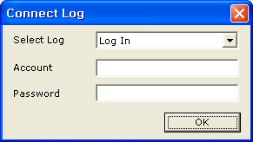

- Select the Log ( Login / Game …), Game is World Name

Log Search

- You can choose the search condition in case you connect to Log Data
- Click Search to open the Search Condition Window

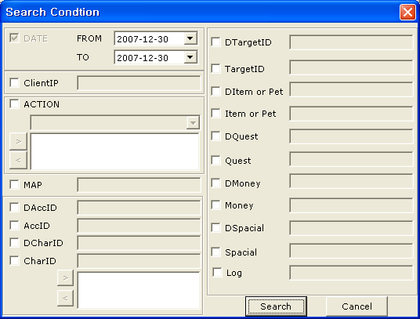

- Date is for the section of search date

- Client IP is IP address (Ex 222.239.77.1)
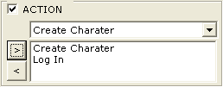
- Action is Log Command, Available to select the plural number
[>] Add the item
[<] Delete the item

- Map is Game Map ID

- DAccID is Account Number ID
- AccID is Account String ID

- DCharID is Character Number ID
- CharID is Character String ID

- DTargetID is Target Character Number ID
- TargetID is Target Character String ID

- DItem or Pet is Item Number or Pet Number
- Item or Pet is Item Name r Pet Name (Now, empty data)

- DQuest is Quest Number ID
- Quest is Quest Name (Now, empty data)

- DMoney is Total Money ( Rune * 1,000,000 + Luna * 1,000 + Cron )
- Money is Money String

- DSecial & Special is special field
- Log is Log Field (EX : Chatting Log)

Log Result

- Output the data for the condition by list.
- The latest data is on the top.

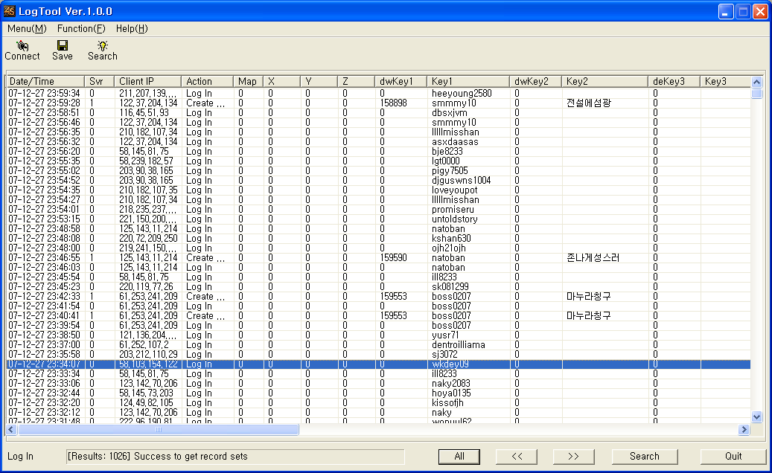

Save Log File

- Click the Save, after if success the search log

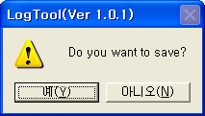

- Log File will be saved by Excel file of Log_YYYYMMDD_HHMISS

